Project Title: Thermal Energy Consumption of Heating and Cooling an Ice Rink

Group Number: Group 8

Group Members: Bui Duc Minh Cao (20937120)
Jake Pedersen (21975066)
Adam Zaltsman (20448350)

Unit: MATH3001 Applied Mathematical Modelling
Unit Coordinator: Professor Benchawan Wiwatanapataphee
Submission Date: 23/10/2026

Abstract

Indoor ice rinks must hold ice below freezing while keeping the air above it comfortable for skaters. This project develops a lumped, steady-state, two-zone thermal model of a hypothetical 80m x 50m x 10m ice rink in Perth, Western Australia. The model has an upper comfort zone controlled by a reverse cycle air conditioner unit, a lower zone adjacent to the ice and floor and an ice surface held at a prescribed temperature. Energy balances based on Conservation of Energy and Newton’s Law of cooling give three linear equations in three unknowns: the lower-zone air temperature, the net thermal power of the upper-zone unit, and the refrigeration thermal power.

For the baseline inputs, the lower-zone temperature is 6.78 °C and the ice refrigeration load is 97.0 kW, independent of outdoor temperature. The upper-zone unit needs −11.5 kW (cooling) on a summer day, +28.8 kW on a winter day and +57.0 kW on a winter night, switching from cooling to heating at an outdoor temperature of 28.1 °C. The combined thermal loads range from 108 kW to 154 kW. Normalised sensitivity analysis showed that the refrigeration load is most sensitive to the air–ice heat-transfer coefficient and to the temperature difference between the upper zone and the ice. In the combined-parameter scenarios, refrigeration loads ranged from 59 kW to 187 kW. The model prediction of 97.0 kW is 28.8% higher than the 75.3 kW published heat flux estimate and 31.7% lower than the 142 kW published refrigeration capacity. The model is a useful tool for initial plant sizing and for identifying which parameters matter most. Radiation, humidity, ventilation and air stratification are not modelled and are the main limitations.

Introduction

Background and Motivation
An indoor ice rink must do two opposite jobs at once; it must keep the ice surface below 0 $℃$ and keep the air above it comfortable for skaters. Heat is supplied to the upper zone and transferred downward toward the ice, and it must be removed by the refrigeration plant, so heating and refrigeration are coupled. Rinks are among the most energy-intensive building types: an average Swedish rink uses about 1090 MWh of energy per year (Karampour and Rogstam 2012, 1), so even a simple model that estimates loads is useful for sizing equipment, comparing building designs (such as shape and size), and determining which parameters most affect thermal load.

Perth has hot summers and mild winters, so a rink there needs the upper zone to be cooled on hot days and heated on cool days and at night. This required a reverse-cycle upper-zone unit (heating and cooling) rather than a heating-only system.

The central modelling challenge is that heat transfers between the upper-zone, lower-zone, floor and ice couples the heating and refrigeration requirements. A change in one temperature or heat-transfer coefficient can therefore affect multiple components of the total thermal load. A two-zone model provides a balance between physical representation and analytical tractability, allowing these interactions to be examined through closed-form solutions.
Objectives
The project has six objectives:
- Develop a lumped two-zone steady-state model (interzone transfer, ice transfer, envelope loss)
- Formulate and analyse the governing energy balance for each Upper-zone, Lower-zone and the ice surface.
- Obtain closed-form expressions for the lower-zone temperature, the upper-zone heating or cooling thermal power and the ice refrigeration power.
- Convert thermal power into thermal energy and interpret the effect of each parameter.
- Validate the predicted loads against published rink data.
- Carry out a sensitivity analysis, one parameter at a time and in combination, to find which parameters matter most.

Scope
The study models only thermal power and thermal energy. Plant efficiency (coefficient of performance) and electrical consumption are outside the scope, so the results are thermal loads, not electricity use. The model is steady state by design, and a transient extension is outside the scope; both exclusions keep the model analytically tractable. The model is for a hypothetical rink in Perth, with geometry and inputs based on standard dimensions and published data; we have not modelled a specific venue.

Organisation of the report
Section 3 reviews the literature. Section 4 develops the model. Section 5 presents the analytical solution, the thermal load calculation, the sensitivity method and the validation measure. Section 6 gives the results. Section 7 discusses them, including validation, limitations, and objectives achieved. Section 8 is the conclusion, Section 9 lists the individual contributions, and the appendices hold the code and calculations.

Literature Review
Previous models
Ice rink energy has been studied with measurement-based and model-based approaches. Karampour and Rogstam (2012) measured and modelled the heat loads of two operating rinks and reported the refrigeration capacity, and Ferrantelli, Viljanen and Kurnitski (2021) analysed energy flows in ice hockey arenas, measured heat flux through the ice pad and gave an analytical formula for the temperature profile in the ice with transient boundary conditions. Seghouani, Daoud and Galanis (2009) developed a model for the yearly energy requirements of indoor rinks.
Zone behaviour and heat transfer
Lin, Liu and Zhang (2023) studied zonal heat and moisture migration inside artificial ice rinks, which supports treating the rink air as distinct zones rather than one volume and supplied the interzone heat-transfer coefficient, and Lin et al. (2022) studied the thermal environment and heat transfer in rinks with different envelopes, which supplied the upper-zone temperature.
Inputs from standards and other fields
Rink dimensions follow the IIHF (2025) rulebook, envelope U-Values from the National Construction Code (ABCB 2022), outdoor temperatures come from the Bureau of Meteorology (2026) climate statistics for Perth Airport and the floor to air coefficient uses a convection correlation from Zeng et al. (2022)
Research gap
Detailed models (CFD and multi-zone with moisture) are accurate but need much more input data and effort. Published measurements are specific to one rink and climate. This project fills a small gap by developing a transparent closed-form model whose equations can be examined directly. The model includes a reverse-cycle upper-zone unit suited to warm climates, where both heating and cooling may be required. Normalised sensitivity analysis is used to rank parameters on a common scale.

Mathematical Model

Physical System

The rink is a rectangular building measuring 80 m × 50 m × 10 m (length, width, height), with a 60 m × 30 m ice pad (1800 m²) at its centre on a 4000 m² floor. The remaining 2200 m² is concrete. The air is split into a lower zone, the first 1 m above the floor, and an upper zone, which includes the remaining 9 m. The ice surface is held at a set temperature (−4 °C) by the refrigeration plant. The upper zone is air-conditioned by a reverse-cycle unit and exchanges heat with the outdoors through the roof and upper walls (the building envelope) and with the lower zone across their shared 4000 m² interface. The lower zone exchanges heat with the upper zone, the ice and the surrounding concrete floor.

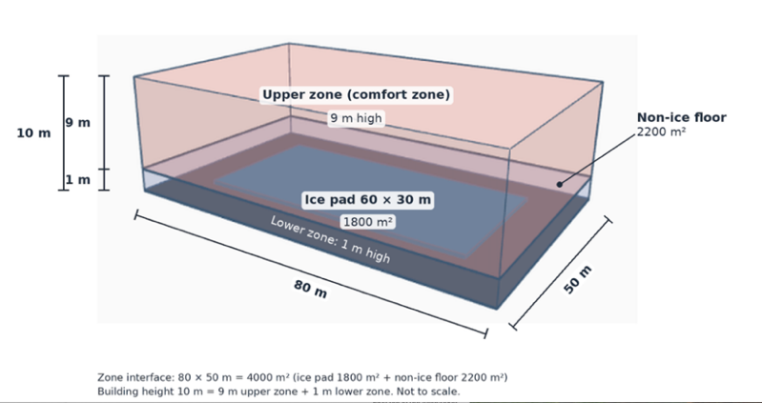
Figure 1. 3D model of the ice rink system (Model by Authors)

Assumptions

Uniform/Well-Mixed Temperatures. Air temperature is uniform within each zone, and the ice surface temperature is uniform. This standard lumped simplification captures the main difference between the cold air at the ice and the comfort zone above, but ignores variation within each zone, including the stratification measured just above the ice (Ferrantelli et al. 2021).

Steady State. The system is in steady state, so each zone’s temperature does not change in time. The plant holds the set points; once reached, the temperature stops changing. This ignores the startup (getting the building to the ideal temperature before opening to the public) and the daily variation in outdoor temperature. Time variation is reintroduced only in the thermal energy calculation (Section 5)

Neglected Mechanism. Occupants, humidity, radiative exchange and other internal heat sources are excluded to keep the model tractable; each needs its own physics and input data, which would turn the closed-form solution into a numerical model and obscure determining the parameters that drive the change in thermal load. These add real load in an operating rink, so neglecting them tends to reduce the predicted load. Ferrantelli et al. (2021) reported that ceiling radiation alone supplied 31.3 W/m² of the ice load in their hall, about 56 kW over the 1800 m² pad. In contrast, other assumptions (such as the well-mixed lower zone) tend to increase the convective load to the ice, so the net effect on the results is not guaranteed to be a lower bound.

Closed System. Air circulates between the two zones, but there is no ventilation with outside air. A real rink would bring in outside air, which would need to be cooled or heated, which adds to the total thermal load.

Lower-Zone Walls Neglected. The lower zone’s 260$m^{2}$ is about 4% of the envelope area and is neglected. This affected the loads by about 1kW or less.

Set Points. The upper-zone temperature $T_{U}$ and Ice temperature $T_{Ice}$ are set points held by the plant (Inputs). The lower-zone temperature $T_{L}$is not a set input and is solved for (Output).

Fixed Floor Temperature. The floor temperature $T_{F}$ is held fixed at 10 °C because the slab is not modelled. The non-ice floor is the sitting and walking area around the rink, which must be comfortable for people, so it is set to the same temperature as the upper zone ($T_{F}=T_{U}$= 10 °C). This is an assumption, not a sourced measurement. $T_{F}$ is therefore the least well-supported input and is varied from 8 to 18 °C in the sensitivity analysis, where it changes ${\dot{Q}}_{C}$by 33% (Section 6).

Reverse-Cycle Upper-Zone Unit. The unit’s net power ${\dot{Q}}_{U}$ is positive when heating and negative when cooling. Both it and the refrigeration plant ${\dot{Q}}_{C}$ are expressed in thermal power, without an efficiency factor.
Variables and Parameters
Table 1: Model variables, baseline values, and the ranges used in the sensitivity analysis.
Symbol | Meaning | Baseline  (Range) | Unit | Source
T_{U} | Upper-zone Temperature | 10  (8.7 to 15) | °C | (Lin et al. 2022, 2)  (Cockburn Ice Area, 2026)
T_{L} | Lower-zone temperature | Computed by the model | °C | Model output
T_{ice} | Ice surface temperature | -4  (–5 to –3) | °C | (Ferrantelli et al. 2021, 6)
T_{env} | Outdoor/environment temperature | 32.1 (Summer Day) / 18.0 (Winter Day) / 8.1 (Winter Night) | °C | (Bureau of Meteorology 2026)
T_{floor} | Non-ice floor surface temperature | 10  (8 to 18) | °C | Assumed
A_{ice} | Ice surface area | 1800 | m² | (IIHF 2025, 17)
A_{env} | Building envelope area (roof and walls) | With height(H) = 9m, => 6340 (roof 4000 + wall 2340) | m² | Derived from assumed geometry
A_{UL} | Interface area between the two zones | 4000 | m² | Ice:1800 + non-ice:2200
$$A_{floor}$$ | Surface area of the floor not covered by ice | 2200 | $$m^{2}$$ | Determined by 4000-1800
U_{UL} | Heat-transfer coefficient between the upper-zone air and the lower-zone air | 4  (2 to 8) | W / (m²K) | (Lin et al 2023, 7)
U_{LI} | Heat-transfer coefficient between lower-zone air and ice surface | 5  (4 to 6) | W / (m²K) | (Karampour and Rogstam 2012, 4)
U_{env} | Outside environment heat-transfer coefficient | 0.45  (0.27 to 0.91) | W / (m²K) | (Australian Building Codes Board 2022, sect. J4D4, J4D6)
$$U_{LF}$$ | Heat-transfer coefficient between lower-zone air and concrete floor surface | 6.4 (5 to 8), with $V=0.2$ m/s  $$U_{LF}=\left\{\begin{aligned}&\begin{matrix}4.0v+5.6 & v≤5\end{matrix} \\ &\begin{matrix}7.15v^{0.78} & v>5\end{matrix}\end{aligned}true\right.$$ | W / (m²K) | (Zeng et al. 2022, 6)
$${\dot{Q}}_{U}$$ | Net power of the upper zone unit (Heating if positive, cooling if negative) | Computed by the model | W | Model output
Q̇_{C} | Required cooling power | Computed by the model | W | Model output

Governing Equations
Conservation of energy
The model is built on the conservation of energy. For a control volume, the rate form of this law is (Wiwatanapataphee 2026, slide 42)
$Ė_{in}-Ė_{out}+Ė_{gen}=\frac{dE_{sorted}}{dt}$ [4.1]
Where $Ė_{in}$ and $Ė_{out}$are the rates at which heat enters and leaves through the boundary, $Ė_{gen}$ is the rate at which heat is added inside the volume, $E_{sorted}$ is the thermal energy it holds. We apply [4.1] to each air zone. Because the air in a zone is well mixed (Assumption 1), its temperature $T_{k}(t)$ is uniform over the zone volume $V_{k}$, so the accumulation term $ρc_{p} ∂T/∂t$ integrates over the zone to $m_{k}c_{p} dT_{k}/dt$, where $m_{k}=ρV_{k}$ is the mass of air in the zone and,
$m_{k}c_{p}\frac{dT_{k}}{dt}=\sum{\dot{Q_{k}} }$ [4.2]
For each zone k= Upper (U) or k = Lower (L), where $Σ{\dot{Q}}_{k}$ is the net rate of heat transfer into the zone, including heat supplied by a plant. Heat Q, the heat transfer rate $\dot{Q}$, and the thermal energy E are distinct throughout. The product $m_{k}c_{p}$ is the thermal capacitance of the zone and its $≠0$. At steady state, the rate of change of temperature vanishes. So [4.2] reduced to $Σ{\dot{Q}}_{k}=0$: heat leaves each zone exactly as fast as it arrives.

Constitutive relationship: Newton's law of cooling
Equation [4.2] applies regardless of the mechanism of heat transfer. To close the model, the heat transfer rate must be expressed in terms of temperature differences. For heat transfer between the adjacent air and the surface, Newton’s Law of cooling gives this rate as $hA_{s}(T_{s}-T_{∞})$ (Wiwatanapataphee 2026, slide 37). So, the linear relationship is used for every heat transfer path in the model,
$$\dot{Q}=UAΔT \left[4.3\right].$$
U is the heat transfer coefficient, A is the area across which heat flows, and $ΔT$ is the temperature difference in the direction of flow. The model has four heat transfer paths, one between each pair of connected temperatures in the thermal network. Each rate is written in the direction shown in the table, so a negative value means that heat flows the other way, and the last column gives the kind of coefficient used for each path. Table 2 lists the four paths.

Table 2: Heat-transfer paths of the two-zone model. Each rate is positive in the direction shown.
Path | Heat-transfer rate (positive direction) | Conductance $K=UA$ (baseline) | Coefficient (source)
Roof and upper walls | $U_{env}A_{env}(T_{env}-T_{U})$, outdoor air → upper zone | $K_{env}=$ 2 853 W/K | Overall U-value of the construction (ABCB 2022)
Zone interface | $U_{UL}A_{UL}(T_{U}-T_{L})$, upper zone → lower zone | $K_{UL}=$ 16 000 W/K | Effective interzone coefficient (Lin, Liu and Zhang 2023, 7)
Ice surface | $U_{LI}A_{ice}(T_{L}-T_{ice})$, lower zone → ice | $K_{LI}=$ 9 000 W/K | Convective coefficient (Karampour and Rogstam 2012, 4)
Non-ice floor | $U_{LF}A_{F}(T_{F}-T_{L})$, floor → lower zone | $K_{LF}=$ 14 080 W/K | Convective coefficient (Zeng et al. 2022, 6)

The four coefficients describe different physical processes: $U_{LI}$ and $U_{LF}$ are convective coefficients between moving air and a surface, the $h$ of Newton's law of cooling, and both increase with air speed $V$: $U_{LI}$= 5W/(m²K) is an assumed baseline within the range given by the ASHRAE correlation $3.41+3.55V$ (Karampour and Rogstam 2012, 4), For the tested range of 4 to 6, air speeds were about 0.2 to 0.7 m/s. $U_{LF}$ from $4.0V+5.6$ (Zeng et al. 2022, 6) V = 0.2. $U_{env}$ is an overall coefficient that combines convection at the inner and outer surfaces of the roof and walls with conduction through them (ABCB 2022). $U_{UL}$ is of a different kind. With no wall separating the two zones, only a horizontal plane 1m above the floor, so $U_{UL}$ is an effective coefficient. It represents the heat carried across it by air moving and mixing between the zones. Its value of 4 W/(m²K) is taken from the zonal ice-rink study of Lin, Liu and Zhang (2023, 7); because it is the least direct of the four, it is varied from 2 to 8 W/(m²K) in the sensitivity analysis.

All coefficients are taken as constant, so every heat-transfer rate is linear in the temperatures. Because only temperature differences are considered, temperatures can be expressed in °C. Radiation from the ceiling to the ice is drawn as a dashed path in Figure 2 but is not modelled (Assumption 3). Figure 2 shows the four paths of Table 2 as the links of the thermal network.
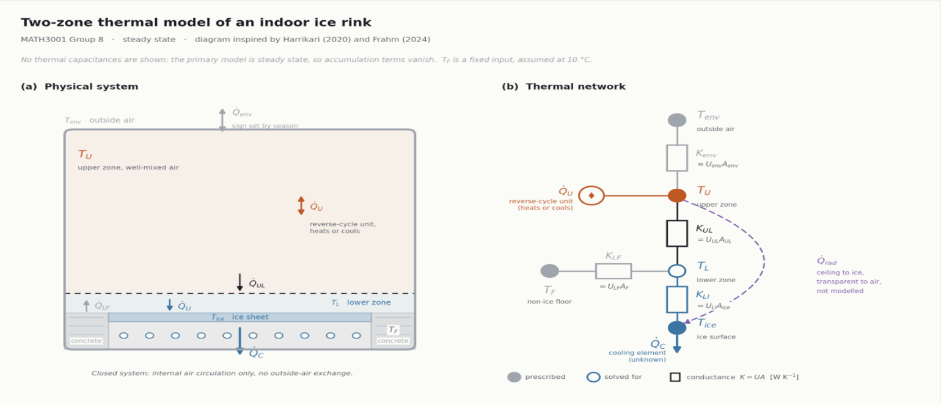
Figure 2. Two-zone thermal model of the rink: (a) physical system; (b) thermal network. Filled nodes are prescribed temperatures; the open node is solved for, and each rectangle has conductance K = UA—layout after Harrikari (2020) and Frahm (2024).
Energy Balance
Applying [4.2] with the rate in Table 2 yields a single balance for each zone. In each balance, heat entering the zone is added, and the heat leaving the zone is subtracted.
Upper zone: The zone receives the thermal power ${\dot{Q}}_{U}$ of the reverse-cycle unit: positive when the unit is heating and negative when the unit is cooling. It also exchanges the heat with the environment through the roof and upper walls,
$$m_{U}c_{p}\frac{dT_{U}}{dt}={\dot{Q}}_{U}+U_{env}A_{env}(T_{env}-T_{U})-U_{UL}A_{UL}(T_{U}-T_{L}) [4.4]$$
Lower-zone. The lower zone has no plants, and it gains heat from the upper zone and the non-ice floor. It loses heat to the ice. According to assumption 5, 260 m² of wall is neglected.
$$m_{L}c_{p}\frac{dT_{L}}{dt}=U_{UL}A_{UL}(T_{U}-T_{L})-U_{LI}A_{ice}(T_{L}-T_{ice})+U_{LF}A_{F}(T_{F}-T_{L}) [4.5]$$

Ice Surface. The ice surface is a boundary of the lower zone and has no thermal capacitance. Its balance, therefore, has no accumulation term: the refrigeration plant removes heat at exactly the rate it arrives from the air, so the ice cooling power is:
$${\dot{Q}}_{C}=U_{LI}A_{ice}(T_{L}-T_{ice}) [4.6]$$

Steady State. The reverse cycle unit maintains the upper-zone temperature. $T_{U}$ as a set point so $dT_{U}/dt=0$ at all times. And in steady state, $dT_{L}/dt=0$ as well. The left-hand sides of [4.4] and [4.5] then vanish, which gives
$$0={\dot{Q}}_{U}+U_{env}A_{env}(T_{env}-T_{U})-U_{UL}A_{UL}(T_{U}-T_{L}) [4.7]$$
$$0=U_{UL}A_{UL}(T_{U}-T_{L})-U_{LI}A_{ice}(T_{L}-T_{ice})+U_{LF}A_{F}(T_{F}-T_{L}) [4.8]$$

The equations [4.6] – [4.8] are the governing equations of the steady state model. Every term has units of watts: $UAΔT$ is W/(m²K) × m² × K, and $mc_{p} dT/dt$ is kg × J/(kg K) × K/s = J/s. The capacitances $m_{U}c_{p}$ and $m_{L}c_{p}$ no longer appear, so their values are needed only if the transient balances [4.4] – [4.5] are solved.

Boundary and Initial Conditions

The model has no spatial domain (air temperature is uniform inside each zone), so the boundary conditions are the prescribed temperatures $T_{env}$ = 32.1, 18.0 or 8.1 °C, $T_{U}$= 10 °C, $T_{F}$ = 10 °C and $T_{ice}$ = −4 °C, together with no heat flow through the lower-zone walls. Because the model is steady state, no initial condition is needed.

Table 3: Boundary conditions of the two-zone model.
Boundary | Type | Condition | Value (range)
Ice surface | Dirichlet: temperature held by the refrigeration plant (Assumption 6) | $$T=T_{ice}$$ | −4 °C (−5 to −3)
Non-ice floor surface | Dirichlet: assumed temperature, slab not modelled (Assumption 7) | $$T=T_{F}$$ | 10 °C (8 to 18)
Roof and upper walls | Robin: exchange with outdoor air at a prescribed $T_{env}$ | $$\dot{Q}=U_{env}A_{env}(T_{env}-T_{U})$$ | 32.1 / 18.0 / 8.1 °C (summer day / winter day / winter night)
Lower-zone walls | Neumann: adiabatic (Assumption 5) | No heat flow | n/a
Upper-zone air | Set point held by the reverse-cycle unit (Assumption 6) | $T_{U}$ fixed, so ${\dot{Q}}_{U}$ is unknown | 10 °C (8.7 to 15)

Table 3 has two features that are important to the solution.
First, where the plant holds a temperature, that temperature is known, and the plant’s power is unknown. In the lower zone, there is no plant, the temperature is unknown, and no power is supplied. The steady state model, therefore, has three unknowns, $T_{L}$, ${\dot{Q}}_{U}$ and ${\dot{Q}}_{C}$, and three equations, [4.6], [4.7], and [4.8]. The equations are linear, and equation [4.8] contains only $T_{L}$, with $U_{UL}A_{UL}+U_{LI}A_{ice}+U_{LF}A_{F}$ is the coefficient. Since every conductance is positive, this coefficient is never zero, so [4.8] has exactly one solution, whereas [4.6] and [4.7] give ${\dot{Q}}_{C}$ and ${\dot{Q}}_{U}$.
Second, $T_{F}$ is the only prescribed temperature that is neither held by a plant nor taken from data, since $T_{env}$ comes from the Bureau of Meteorology (2026) statistics. The slab beneath the floor is not modelled, so $T_{F}$ is an assumed value and, as the least certain input, is varied from 8 to 18 °C.
Equations [4.6] – [4.8] contain no time derivative, so the steady state model needs none. Solving the transient balances [4.4] – [4.5] would require an initial lower-zone temperature, $T_{L}(0)=T_{L0}$. This is outside the scope of the project.

Mathematical Analysis

Analytical Solution and Properties
The steady-state equations [4.6] – [4.8] are three linear equations in the three unknowns $T_{L}$, ${\dot{Q}}_{U}$ and ${\dot{Q}}_{C}$. Because $T_{U}$ is fixed, the lower-zone balance [4.8] contains only $T_{L}$, so it is solved first, [4.6] and [4.7] then give ${\dot{Q}}_{C}$ and ${\dot{Q}}_{U}$.
Rearranging [4.8] and collecting the $T_{L}$ terms give:
$$(U_{UL}A_{UL}+U_{LI}A_{ice}+U_{LF}A_{F})T_{L}=U_{UL}A_{UL}T_{U}+U_{LI}A_{ice}T_{ice}+U_{LF}A_{F}T_{F}$$
So that:
$$T_{L }= \frac{U_{UL}A_{UL}T_{U}+U_{LI}A_{ice}T_{ice}+U_{LF}A_{F}T_{F}}{U_{UL}A_{UL}+U_{LI}A_{ice}+U_{LF}A_{F}} [5.1]$$
Substituting [5.1] into [4.6] gives the cooling power:
$${\dot{Q}}_{C}=U_{LI}A_{ice}\left(\frac{U_{UL}A_{UL}T_{U}+U_{LI}A_{ice}T_{ice}+U_{LF}A_{F}T_{F}}{U_{UL}A_{UL}+U_{LI}A_{ice}+U_{LF}A_{F}}-T_{ice}\right) [5.2]$$
and substituting it into [4.7] gives the net power of the upper-zone unit:
${\dot{Q}}_{U}=U_{UL}A_{UL}\left(T_{U}-\frac{U_{UL}A_{UL}T_{U}+U_{LI}A_{ice}T_{ice}+U_{LF}A_{F}T_{F}}{U_{UL}A_{UL}+U_{LI}A_{ice}+U_{LF}A_{F}}\right)-U_{env}A_{env}\left(T_{env}-T_{U}\right)$ [5.3]
These results show four features of the model:
- $T_{L}$ is the average of $T_{U}$, $T_{ice}$ and $T_{floor}$ weighted by their conductance. It must therefore lie between the coldest and warmest of these temperatures.
- Outdoor conditions do not affect the cooling power as $U_{env}$, $A_{env}$, and $T_{env}$ do not appear in [5.1] or [5.2]. This is because the envelope exchanges heat only with the upper zone. Since $T_{U}$ is fixed, a change in the heat flow through the envelope only changes how much heating or cooling the upper zone needs.
- The cooling power depends only on temperature differences. With $θ_{U}=T_{U}-T_{ice}$ and $θ_{F}=T_{F}-T_{ice}$, and subtracting $T_{ice}$ from both sides of [5.1] gives
$$T_{L}-T_{ice}=\frac{U_{UL}A_{UL}θ_{U}+U_{LF}A_{F}θ_{F}}{U_{UL}A_{UL}+U_{LI}A_{ice}+U_{LF}A_{F}}$$
And multiplying by $U_{LI}A_{ice}$,
$${\dot{Q}}_{C}=U_{LI}A_{ice} \frac{U_{UL}A_{UL} θ_{U}+U_{LF}A_{F} θ_{F}}{U_{UL}A_{UL}+U_{LI}A_{ice}+U_{LF}A_{F}} \left[5.4\right]$$
- The heating and cooling loads are linked, and combining [4.8] with [4.6] gives
$${\dot{Q}}_{C}=U_{UL}A_{UL}\left(T_{U}-T_{L}\right)+U_{LF}A_{F}\left(T_{F}-T_{L}\right) \left[5.5\right]$$
All the heat entering the lower zone, from the air above and from the surrounding floor, must be removed at the ice. In winter, ${\dot{Q}}_{U}$ is positive (heating) and in summer ${\dot{Q}}_{U}$ is negative (cooling). As the net power ${\dot{Q}}_{U}$ can be positive or negative; we must consider how to model the upper thermal plant correctly. We therefore split ${\dot{Q}}_{U}$into heating load ${\dot{Q}}_{H}$ and upper-zone cooling load ${\dot{Q}}_{UC}$ were,
${\dot{Q}}_{H}=\max\left({\dot{Q}}_{U},0\right) \& {\dot{Q}}_{UC}=\max\left(-{\dot{(Q}}_{U}),0\right)$.
If ${\dot{Q}}_{U}$ is positive, heating is required, so ${\dot{Q}}_{H}={\dot{Q}}_{U}$and ${\dot{Q}}_{UC}$= 0. If ${\dot{Q}}_{U}$ is negative, the unit is cooling, so ${\dot{Q}}_{UC}={-\dot{Q}}_{U},$which is a positive number, and ${\dot{Q}}_{H}=0$. Only one of the two loads is non-zero at any time. Equation [5.6] is then applied to each load. Splitting ${\dot{Q}}_{U}$in this way, it keeps the heating and cooling energy separate, which the absolute value $\left|{\dot{Q}}_{U}\right|$would not.
- Switching temperature. ${\dot{Q}}_{U}$ is linear in $T_{env}$with slope ${-U}_{Env}A_{Env}(-2.853 kW per K baseline)$. Setting ${\dot{Q}}_{U}= 0$in [5.3] gives the switching temperature$T_{env}* =T_{U}+\frac{U_{UL}A_{UL}\left(T_{U}-T_{L}\right)}{U_{env}A_{env}} ≈$ $28.1 °C$. Below $T_{env}*$the unit heats the upper zone, and above it the unit cools it.

Energy over a period. The thermal energy over a period from t₁ to t₂ is the time integral of the thermal power,
$$E=\int_{t_{1}}^{t_{2}}{\dot{Q}}\left(t\right) dt \left[5.6\right]$$
When Q̇ is constant over the period Δt = t₂ − t₁, as${\dot{Q}}_{C}$ is, this reduces to
$$E=\dot{Q}∆ t \left[5.7\right]$$
With Q̇ in kW and Δt in hours, E is in kWh.
Normalized sensitivity
The one-at-a-time ranges in Section 6 cannot be compared fairly, because the parameters have different units and their ranges were chosen separately. Each parameter is therefore also assessed with a normalised sensitivity coefficient,
$$S_{x}=\frac{\left[{\dot{Q}}_{C}\left(1.01 x\right)-{\dot{Q}}_{C}\left(x\right)\right]/{\dot{Q}}_{C}\left(x\right)}{0.01} \left[5.8\right]$$$S_{x}$has no units, so heat transfer coefficients and temperatures can be compared directly. Since [5.4] shows that ${\dot{Q}}_{C}$ depends only on temperature differences, the temperatures are entered as the differences $θ$U and $θ_{F}$ rather than in degrees Celsius, where the arbitrary zero would make a 1% change meaningless.
In addition to the one-at-a-time variation, combined scenarios were evaluated in which several parameters move together to the ends of their ranges (Section 6).
Validation Measure
The model was checked with published measurements from operating ice rinks. The errors are measured as:
$${Error}_{\%}=\frac{{\dot{Q}}_{model}-{\dot{Q}}_{ref}}{{\dot{Q}}_{ref}}×100\% \left[5.9\right]$$
Verification (equations solved correctly) is kept separate from validation (the predictions are realistic)
Implementation and Verification
The model is implemented in Python (Appendix). A single function evaluates [5.1] – [5.3] for a given set of inputs and returns $T_{L}$, ${\dot{Q}}_{C}$and${\dot{Q}}_{U}$. The script evaluates the three baseline conditions, varies each input over its range with the others at baseline, computes the normalised sensitivity [5.8] from a 1% increase in each input, and evaluates the combined scenarios. The baseline results agree with a hand calculation and with an independent Excel implementation (Figure 3) to the precision reported.

Results
To verify that our model calculations produced reasonable results, we utilized an Excel spreadsheet. Figure 3 is our final Excel sheet that displays the calculated values for $T_{L}$, ${\dot{Q}}_{C}$and${\dot{Q}}_{U}$during a summer day.

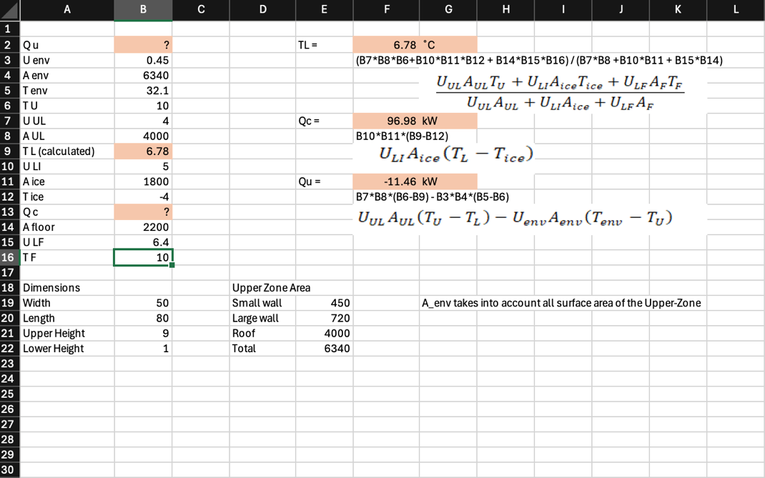
Figure 3. Excel calculation of lower zone temperature, required cooling thermal power and required upper zone heat thermal power (Figure by Authors)
With our verified calculations, we could use the Excel spreadsheet to determine the lower zone temperature and the required thermal power for the ice-cooling unit and the upper-zone reverse-cycle unit. As mentioned earlier in our analytical solution section, we solved for the lower temperature value first, and our calculated value was consistently $6.78℃$. This was due to the lower-temperature equation not varying with the change in environmental temperature. Once we determined the lower temperature, we solved for the thermal power requirements of the ice cooling unit and the upper-zone reverse-cycle unit. We focused on determining these values for a summer day, a winter day and a winter night in Perth, as this gave a range of distinct environmental temperature values. Figure 4 and table 4 displays these values.

Figure 4. Graph of the thermal power requirements of the ice cooling unit and upper-zone reverse-cycle unit (Figure by Authors)
Figure 4 shows that the ice cooling power stays at 97.0 kW at every outdoor temperature, while the upper-zone power falls linearly with outdoor temperature, with a constant slope of −2.853 kW/K. It crosses zero at about 28.1 °C: below this temperature the unit heats the upper zone, and above it the unit cools it.
Baseline loads
Table 4: Calculated values of key values based on different environmental temperatures
Outdoor condition | $$T_{env}(℃)$$ | $$T_{L}(℃)$$ | $${\dot{Q}}_{C} (kW)$$ | $${\dot{Q}}_{U} (kW)$$
Summer day | 32.1 | 6.78 | 97.0 | -11.5 (Cooling)
Winter day | 18.0 | 6.78 | 97.0 | +28.8 (Heating)
Winter night | 8.1 | 6.78 | 97.0 | +57.0 (Heating)
The lower-zone air is at 6.78$℃$ between the ice $(-4℃)$ and the upper-zone (10$℃)$ and the refrigeration load maintained 97kW in all three conditions because the outdoor temperature only acts on the upper zone, whose temperature the unit holds fixed, and the floor temperature is also fixed. No heat path carries the weather down to the ice. The upper-zone unit changes with the weather, it cools on a summer day and heats on a winter day and night with the largest load on the winter night. A heating only system could not hold 10$℃$ on hot Perth days.
Total thermal load. Adding the refrigeration load to the upper-zone heating or cooling load gives a combined thermal load of 108.5 kW (summer day), 125.8 kW (winter day) and 154.0 kW (winter night). Held for 24 hours, these give 2604, 3019 and 3696 kWh by [5.7], of which refrigeration alone is 97.0 × 24 = 2328 kWh. For a winter day with 12 hours during daytime and 12 hours at night-time conditions, the upper-zone heating energy is 12 × 28.8 + 12 × 57.0 = 1030 kWh, so the total is 2328 + 1030 = 3358 kWh per day.
One at time sensitivity
Table 5: Sensitivity of ${\dot{Q}}_{C}$ and ${\dot{Q}}_{U}$(winter day) to each parameter over its range, others at baseline.
Parameter | Range | $${\dot{Q}}_{C}(kW)$$ | Change in kW(%) | $${\dot{Q}}_{U}(kW)$$ | Change in $kW(\%)$
$$T_{U}$$ | 8.7 to 15 | 92.2 to 115.4 | 24 | 12.8 to 90.3 | 269
$$T_{Ice}$$ | -5 to -3 | 103.9 to 90.1 | 14 | 32.4 to 25.1 | 26
$$T_{Floor}$$ | 8 to 18 | 90.5 to 122.9 | 33 | 40.3 to -17.4 | 200
$$U_{UL}$$ | 2 to 8 | 89.5 to 105.4 | 16 | 9.6 to 50.4 | 142
$$U_{LI}$$ | 4 to 6 | 81.3 to 111.3 | 31 | 20.4 to 36.4 | 55
$$U_{LF}$$ | 5 to 8 | 94.5 to 99.4 | 5 | 33.2 to 24.5 | 30
$$U_{env}$$ | 0.27 to 0.91 | 97 to 97 | 0 | 37.9 to 5.4 | 113

Normalized Sensitivity
Table 6: Normalised sensitivity S of ${\dot{Q}}_{C}$to each input at baseline [5.8].
Parameter | $$S_{x}$$
$$U_{LI}$$ | 0.768
$$θ_{U}=T_{U}-T_{ice}$$ | 0.532
$$θ_{F}=T_{F}-T_{ice}$$ | 0.468
$$U_{UL}$$ | 0.122
$$U_{LF}$$ | 0.107
$$U_{env}$$ | 0.000
Table 6 ranks the input on a common scale. A 1% increase in $U_{LI}$ raises ${\dot{Q}}_{C}$ by 0.77%, more than any other input; the effect is below 1% because a larger $U_{LI}$ also lowers $T_{L}$, which partly offsets the increase. The two temperature differences follow (0.53 and 0.47), and their coefficients sum to 1 because ${\dot{Q}}_{C}$ is a linear combination of $θ_{U}$ and $θ_{F}$ [5.4]. $U_{UL}$ and $U_{LF}$ have a small effect, and $U_{env}$ has none, because the envelope exchanges heat only with the upper zone, whose temperature is fixed.

Combined parameters scenario
Table 7 shows the effect of changing several inputs together: a hot day with a warm floor, a poor envelope, and every input at the low load or high load end of its range. $U_{env}$ stays at its baseline value in the last two rows, because it does not affect ${\dot{Q}}_{C}$.
Table 7: Combined-parameter scenarios (${\dot{Q}}_{U}>0$ heating, ${\dot{Q}}_{U}<0$ cooling).
Scenario | Inputs changed from baseline | $T_{env}$ (°C) | $T_{L}$ (°C) | ${\dot{Q}}_{C}$ (kW) | ${\dot{Q}}_{U}$ (kW)
Baseline |  | 32.1  18  8.1 | 6.78 | 97.0 | -11.5  +28.8  +57.0
Summer day, warm floor | $T_{F}=18$ °C | 32.1 | 9.66 | 122.9 | −57.6
Summer day, warm floor, high air–ice coefficient | $T_{F}=18$ °C, $U_{LI}=6$ | 32.1 | 9.06 | 141.0 | −48.0
Summer day, poor envelope | $$U_{env}=0.91$$ | 32.1 | 6.78 | 97.0 | −75.9
Winter night, poor envelope | $$U_{env}=0.91$$ | 8.1 | 6.78 | 97.0 | +62.5
Winter night, poor envelope, high interzone coefficient | $U_{env}=0.91$, $U_{UL}=8$ | 8.1 | 7.71 | 105.4 | +84.2
Low load, winter day | $T_{F}=8$ °C, $U_{LI}=4$, $T_{U}=8.7$ °C, $T_{ice}=-3$ °C | 18.0 | 6.18 | 66.1 | +13.9
High load, winter day | $T_{F}=18$ °C, $U_{LI}=6$, $T_{U}=15$ °C, $T_{ice}=-5$ °C | 18.0 | 10.75 | 170.1 | +59.4
All low-load ends, winter day | Low load, and $U_{UL}=2$, $U_{LF}=5$ ($U_{env}$ at baseline) | 18.0 | 5.19 | 59.0 | +1.5
All high-load ends, winter day | High load, and $U_{UL}=8$, $U_{LF}=8$ ($U_{env}$ at baseline) | 18.0 | 12.30 | 186.8 | +77.9
Combined variation widens the range of the ice load considerably, from 59.0 to 186.8 kW, compared with 81.3 to 122.9 kW for the largest single-input changes in Table 5.

Discussion

Objectives Achieved
Table 8: Status of Objective
No. | Objective | Status | Where
1 | Develop a lumped two-zone steady-state model | Achieved | Section 4, Figure 2
2 | Formulate the governing energy balances | Achieved | [4.4] – [4.8]
3 | Obtain closed-form expressions for $T_{L}$, ${\dot{Q}}_{U}$ and ${\dot{Q}}_{C}$ | Achieved, and verified by hand, in Excel and in Python | [5.1] – [5.3], Appendix C
4 | Convert thermal power into thermal energy and interpret each parameter | Partly achieved: daily energy at constant and day–night conditions; an annual estimate from Perth temperature data remains future work | Section 6
5 | Validate the predicted loads against published data | Partly achieved: the ice load is compared with two published values; no published data were found for the upper-zone load | Table 9
6 | Carry out a sensitivity analysis, one parameter at a time and in combination | Achieved | Tables 5–7

Interpretation

The central result of the model is the refrigeration load is independent of outdoor temperature in the model. Equation [5.1] and [5.2] contain neither $T_{env}$nor $U_{env}$ so the ice load stays at 97.0kW in every condition, while the effect of outdoor temperature falls on the upper zone unit. This follows from our assumption rather than from physics. The reverse cycle unit holds $T_{U}$ fixed, $T_{U}$ fixed ,the building exchanges no air with the environment and radiation is not modelled, So the envelope only affects the upper zone. Neglecting the lower-zone’s walls has little effect (about 1kW or less , Assumption 5).In an operating ice rink, humidity and radiation from the roof would carry part of the outdoor load down to the ice.

For the upper zone, the switching temperature of about 28.1 °C separates heating from cooling. Perth’s mean February maximum of 32.1 °C (Bureau of Meteorology 2026) lies above it, so the unit must be able to cool as well as heat, and a heating-only system could not hold 10 °C in summer.
The envelope behaves less intuitively. On a winter day the outdoor air (18.0 °C) is warmer than the rink air (10 °C), so heat flows in through the roof and walls and partly offsets the heat that the upper zone passes down to the lower zone. A better-insulated envelope therefore raises the daytime heating load, from 5.4 kW at $U_{env}=0.91$ W/(m²K) to 37.9 kW at $U_{env}=0.27$ W/(m²K). At night the effect reverses, because the outdoor air is colder than the rink, and a poor envelope raises the heating load to 62.5 kW. Insulation for a rink in a mild climate should therefore be judged over the whole year, not on the coldest night alone.

Comparison with Published Results
Table 9: Comparison of the modelled ice cooling power with published values.
Reference | Published value | Reference power (kW) | Model ${\dot{Q}}_{C}$ (kW) | Error (%)
Ferrantelli, Viljanen and Kurnitski (2021) | Average heat flux through the ice pad, 41.85 W/m², multiplied by the modelled ice area of 1800 m² | 75.3 | 97.0 | +28.8
Karampour and Rogstam (2012) | Average refrigeration capacity of a rink with an ice sheet of about 1800 m² | 142 | 97.0 | −31.7

The model lies between the two references, but neither measures the quantity the model computes, so this is not evidence that the model is accurate. Our model with 97.0kW is convection alone. The 41.85 W/m² of Ferrantelli, Viljanen and Kurnitski (2021) is the total heat flux into the ice pad, most of which they attribute to radiation from the ceiling, and the 142 kW of Karampour and Rogstam (2012) is the whole refrigeration load, including radiation, lighting, ice resurfacing and pumping.

The competing effects may partially offset one another. The model drives it with $T_{L}-T_{ice}=10.8$ K, whereas Ferrantelli, Viljanen and Kurnitski (2021) evaluate convection with the air 5 mm above the ice, which was measured at −3.5 °C, only about 1.1 K above the −4.64 °C ice surface. At the same time, radiation and other loads are left out.
Verification is strong: the closed-form solution, an independent Excel implementation and a hand calculation agree to the precision reported. Validation is limited to two references from different rinks and climates, and no published data were found for the upper-zone load, so ${\dot{Q}}_{U}$ is unvalidated.

The published load breakdowns make this comparison quantitative. Karampour and Rogstam (2012) estimate a convection–condensation load of 51.5 kW, a radiation load of 33 kW and a lighting load of 13.1 kW for their 1800 m² ice sheet. Ferrantelli, Viljanen and Kurnitski (2021) split their heat flux of 41.85 W/m into components, including 72.8% of radiation, 14.3% of lighting, 10.5 % convection and 2.4 % condensation. The model’s convective load of 53.9 W/m² (97.0 kW over 1800 m²) is about twice the convection–condensation estimate of Karampour and Rogstam (28.6 W/m²) and about twelve times the convection estimated by Ferrantelli, Viljanen and Kurnitski.

Sensitivity to Parameters
The ice load is most sensitive to $U_{LI}$. Better data on the air speed over the ice, which sets $U_{LI}$ through the ASHRAE correlation, would therefore improve the prediction most. The temperature differences $θ_{U}$ and $θ_{F}$ follow at 0.53 and 0.47. These two coefficients have a direct physical meaning. Equation [5.5] splits the ice load into the heat that reaches the lower zone from the upper zone and the heat that reaches it from the non-ice floor. Because $T_{U}=T_{F}$ at baseline, both terms have the same temperature difference, 3.224 K, so their shares of the ice load equal $S_{θ_{U}}$ and $S_{θ_{F}}$: 51.6 kW (53%) comes down from the upper zone, and 45.4 kW (47%) comes from the floor. The floor, therefore, supplies almost half of the refrigeration load.
Table 10: Heat inputs to the lower zone at baseline
Heat input to the lower zone | $UA$ (W/K) | Temperature difference (K) | Heat flow (kW) | Share of ${\dot{Q}}_{C}$ (%)
From the upper zone, $U_{UL}A_{UL}(T_{U}-T_{L})$ | 16 000 | 3.224 | 51.6 | 53
From the non-ice floor, $U_{LF}A_{F}(T_{F}-T_{L})$ | 14 080 | 3.224 | 45.4 | 47
Total, equal to ${\dot{Q}}_{C}$ from [4.6] |  |  | 97.0 | 100

Limitations

The model neglects radiation, occupants, humidity and ventilation and treats the zones as well mixed. Some of these simplifications make the predicted refrigeration load too low, and others make it too high, so the model alone cannot tell us whether its overall error is an underprediction or overprediction. The results should not be read as a lower bound of the true load.

Radiation has a big impact, as Ferrantelli et al (2021) attributed 31.3W/$m^{2}$ if the ice load in their hall to ceiling radiation 72.3% of the 41.85 W/$m^{2}$ average ice heat flux. If that split is representative, then the non-radiative share of the measured flux (convection, condensation and lighting) is only about 10W/$m^{2}$ (roughly 19kW over 1800$m^{2}$) and convection alone is about 4.5W/$m^{2}$. Because these loads are excluded, the modelled 97.0 kW refrigeration load is entirely attributed to convective heat transfer through the lower-zone air. This corresponds to 53.9 W/$m^{2}$. Therefore, the model seems to count some heat as convection that is really radiation. Comparing the measured total (28.8% high) does not mean the model gets the convection and radiation shares right, because its errors in each partly cancel. Further limitations are:

Fixed floor temperature: $T_{Floor}$ = 10$℃$ is assumed and has the largest effect on ${\dot{Q}}_{C }$ over its tested range (33% against 31% for $U_{LI})$, even thought $U_{LI}$ has the largest normalized sensitivity (Section 6.2) A better treatment would solve a simple concrete slab model.

Fixed set point: Fixing $T_{U}$ and $T_{Ice}$ means the plant is assumed to hold them regardless of load; this ignores plant capacity limits and any transient response.

Steady state: Start-up, daily cycling and ice resurfacing are not modelled.

Closed system: With no ventilation, no radiation and the lower-zone walls being neglected, nothing carries the outdoor conditions to the ice, so the ice cooling load ${\dot{Q}}_{C}$ This is independent of the weather; this would not hold in a real rink.

Well-mixed lower zone: Overstates convection. Measured air next to the ice is only about 1K above the surface (Section 7.3)

Limited Validation: Only two references from different rinks for ${\dot{Q}}_{C}$ while unable to find reference data for ${\dot{Q}}_{U}$.

Thermal loads only: No plant efficiency, so the results are not for electrical use.

Strengths

The model is transparent, with closed-form equations that can be checked by hand, and it separates verification from validation. It makes clear structural predictions ($T_{L}$ as a weighted average, constant refrigeration load ${\dot{Q}}_{C}$ , linear ${\dot{Q}}_{U}$, a switching temperature) and its combined scenario analysis shows how certain inputs compound. It includes a reverse-cycle unit appropriate for Perth’s conditions.

Conclusions
Key Outcomes: A lumped, steady-state two-zone model of an indoor ice rink in Perth was formulated and solved in closed form. For baseline inputs, the lower-zone air is 6.78$℃$ and the ice refrigeration load is 97.0 kw regardless of the weather. The upper-zone reverse cycle unit needs = 11.5kW (cooling) on a summer day, +28.8 kW on a winter day and +57.0 kW on a winter night, switching between cooling and heating at 28.1$℃.$ Combined thermal loads are 108.5 kW, 125.8 kW, and 154.0 kW across the three conditions, or roughly 2.6 to 3.7 MWh per day under constant conditions.
Sensitivity: The refrigeration load is most sensitive to the air-ice heat-transfer coefficient $U_{LI}$ (S = 0.77), followed by the Upper-Zone-Ice $θ_{U }$ $(0.53)$ and Floor-Ice $θ_{F}$ (0.47) temperature differences . The envelope coefficient affects only the upper-zone load. Combined scenarios widen the refrigeration range to 59-187 kW.

Validation: The refrigeration load is 28.8% above the Ferrantelli et al (2021) ice heat flux, likely because the well-mixed lower-zone overstates convection and 31.7 % below the Karampour and Rogstam (2012) refrigeration capacity, which included loads the model neglects. The model is plausible but not validated closely, as the upper-zone loads could not be compared with any published data.
Contributions: The project gives a transparent model with an analytical solution that shows the structural results (conductance- weighted lower-zone temperature, a constant refrigeration load, a linear unit loading with a switching temperature), applies a reverse-cycle unit suited to Perth’s climate and ranks parameters with normalised and combined sensitivity analysis.
Limitations. Radiation, humidity, occupants, ventilation and air stratification are not modelled. Additionally, the floor temperature was assumed, the upper-zone and floor temperature are set, and the envelope, radiation and ventilation do not act on the lower-zone, the refrigeration load is independent of the weather. The sign of the net error from the neglected effects is uncertain.
Future work to take the report further:
- Add a thermal to electrical conversion using plant efficiency (COP) to estimate electrical use. This was excluded here to keep the results in terms of thermal loads.
- Quantify the neglected loads starting with radiation, ventilation and humidity and test whether they offset the overestimate from the well-mixed lower-zone.
- Replace the well-mixed lower zone with a stratified layer and model the slab to replace the fixed floor temperature.
- Extend to a transient model with hourly Perth temperatures to estimate annual energy and compare the upper-zone loads with published data. The transient extension was excluded here to keep the model analytically traceable.

Individual Contributions

Member | Contribution
Bui Duc Minh Cao | Literature review, governing equations, analytical solution and model properties, Python implementation, sensitivity and validation measure, thermal diagram, project plan and schedule
Jake Pedersen | Literature review, Excel modelling, introduction, 3D models, problem statement, report preparation, results, presentation, proofreading and formatting.
Adam Zaltsman | Literature review, referencing, project objectives, proposed solution, expected outcomes, report preparation and presentation.

References
Australian Building Codes Board (ABCB). 2022.” Part J4 Building Fabric.” National Construction Code 2022, Volume One,
https://ncc.abcb.gov.au/editions/ncc-2022/adopted/volume-one/j-energy-efficiency/part-j4-building-fabric.
Bureau of Meteorology. 2026. "Climate Statistics for Australian Locations: Perth Airport, Station 009021." Commonwealth of Australia. http://www.bom.gov.au/climate/averages/tables/cw_009021.shtml.
Cockburn Ice Arena. 2026. “FAQs for Schools- Questions Frequently Asked by Teachers”. https://www.cockburnicearena.com.au/school-faqs/.
Ferrantelli, Andrea, Klaus Viljanen, and Jarek Kurnitski. 2021. "Energy Analysis in Ice Hockey Arenas and Analytical Formula for the Temperature Profile in the Ice Pad with Transient Boundary Conditions." Advances in Building Energy Research 15 (4): 499–522.
https://doi.org/10.1080/17512549.2019.1615549.
Frahm, Moritz. 2024. “Occupant-Oriented Demand Response with Model Predictive Heating Control in a Multi-Zone Residential Building”. PhD thesis, Karlsruhe Institute of Technology. https://publikationen.bibliothek.kit.edu/1000174124.
Harrikari, Atte-Mainio. 2020. “Multivariate Analysis of Heat Transfer in Ice Rinks with Carbon Dioxide as a Refrigerant”. Master's thesis, Aalto University, School of Chemical Engineering. https://aaltodoc.aalto.fi/items/00eeb8ac-a17e-41af-bb4b-b065d7989f76
International Ice Hockey Federation. 2025. “IIHF Official Rulebook 2025/26”. Version 1.1. Zurich: IIHF. https://blob.iihf.com/iihf-media/iihfmvc/media/contentimages/3_the_iihf/sa2025-26_iihf_rulebook_22122025-v1.pdf .
Karampour, Mazyar, and Jörgen Rogstam. 2012. “Measurement and Modelling of Ice Rink Heat Loads.” https://www.diva-portal.org/smash/get/diva2:542333/FULLTEXT01.pdf.
Lin, Wenyu, Xiaohua Liu, and Tao Zhang. 2023. "Experimental and Numerical Study of Zonal Heat and Moisture Migration inside Artificial Ice Rinks." Building and Environment 245: 110897. https://www.sciencedirect.com/science/article/pii/S0360132323009241 .
Lin, Wenyu, Xiaohua Liu, Shaojie Li, and Tao Zhang. 2022. "Investigation on Thermal Environment and Heat Transfer Characteristics in Ice Rinks with Different Envelopes." Building and Environment 219: 109250.
https://doi.org/10.1016/j.buildenv.2022.109250.
Seghouani, Lotfi, Ahmed Daoud, and Nicolas Galanis. 2009. “Prediction of Yearly Energy Requirements of Indoor Ice Rinks.” Energy and Buildings 41 (5): 500–511. https://doi.org/10.1016/j.enbuild.2008.11.014
Wiwatanapataphee, Benchawan. 2026. “Lecture 6 — Heat Transfer Modelling.” Lecture slides, MATH3001 Applied Mathematical Modelling, Curtin University, September 1, 2026.
Zeng, Haoyu, Chao Lu, Li Zhang, et al. 2022. “Prediction of Temperature Distribution in Concrete under Variable Environmental Factors through a Three-Dimensional Heat Transfer Model.” Materials (Basel, Switzerland), 15(4), 1510. https://doi.org/10.3390/ma15041510.

Appendices

Appendix A: Project Repository
The code, figures and calculations for this report are kept in the group repository,
https://github.com/mocthemocc/applied-mathematical-modelling-2026

Appendix B: Python code

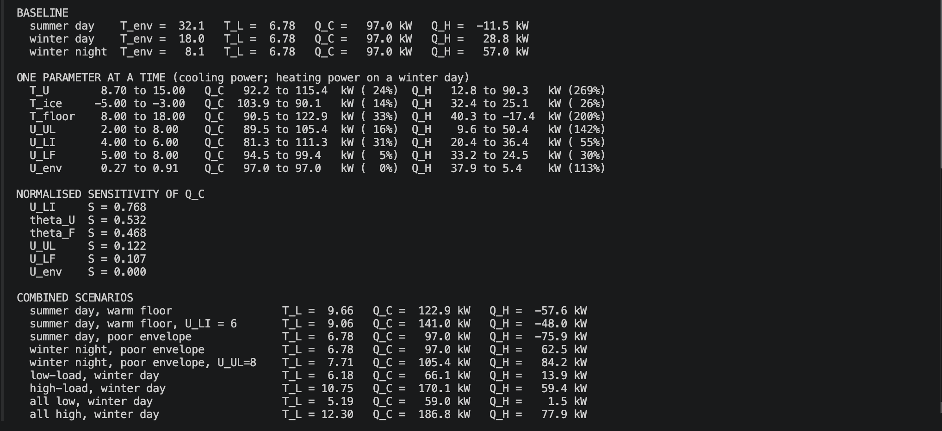

Appendix C: Hand Verification of the Baseline Result

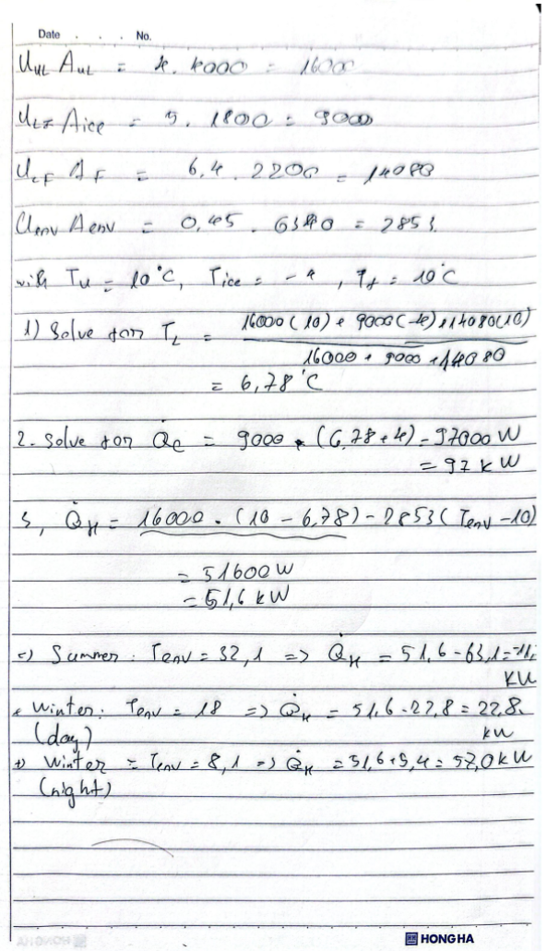

Appendix D: Validation error calculations

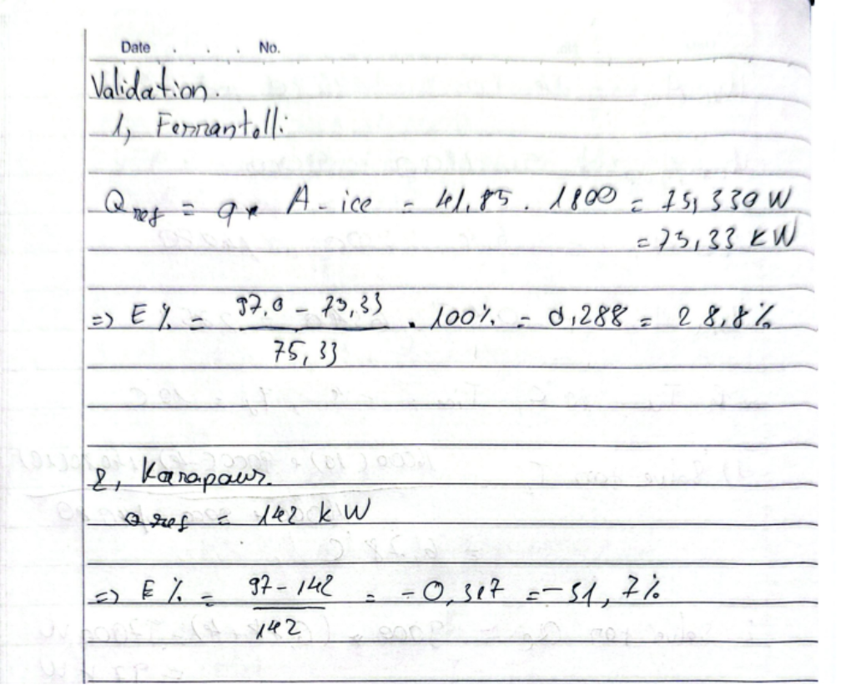

The code, figures and calculations for this report are kept in the group repository,
https://github.com/mocthemocc/applied-mathematical-modelling-2026

